**Password for bandit24**

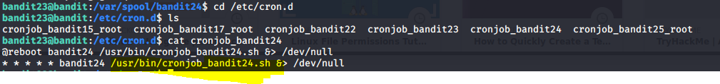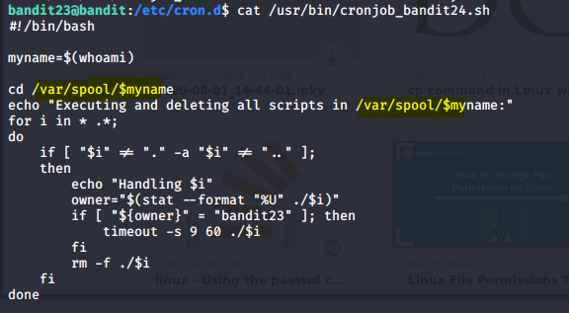

So we have permission to run in /var/spool/bandit24

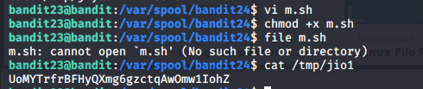

**Password for bandit25**

**Creating script in /tmp folder**

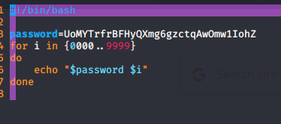

chmod +x script.sh



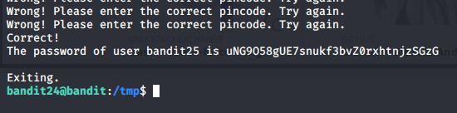



**Password for bandit26**

It is private key that is used for login

We will copy it in our system and login for bandit26 with it

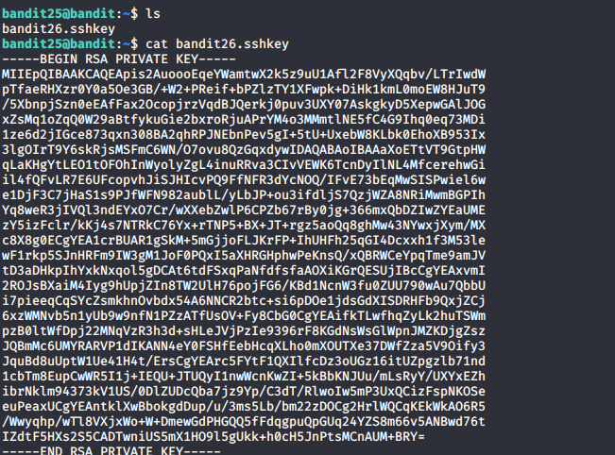

And make it executable file and name it id_rsa like so that it get validated in bandit26

